Final Year Project

## FYP Group

**Wahab Ijaz 19F-0118**

**Waseem Akram 19F-0300**

**Usama Faisal 19F-0321**

**Supervised by Faryal Saud**

**Department of Computer Science**

**National University of Computer and Emerging Science Chiniot-Faisalabad Campus, Pakistan**

**2022**

**Anti-Plagiarism Declaration**

This is to declare that the above publication produced under the:

**Title:**

is the sole contribution of the author(s) and no part hereof has been reproduced on **as it is** basis (cut and paste) which can be considered as **Plagiarism.** All referenced parts have been used to argue the idea and have been cited properly. I/We will be responsible and liable for any consequence if violation of this declaration is determined.

Date:

Student 1

Name:

Student 2

Signature: Name:

Student 3

Signature: Name:

Signature:

Food Grid

## Abstract

Food Grid would provide a platform that helps people to order the food according to their exact requirements. The application's main purpose is to help people know the ingredients and calories in their food. Users would create their food according to the required calories and ingredients. Food Grid helps them to create the exact order by telling them that the specific item contains specific Calories.

Table of Contents

1. Introduction 1

2. Vision Document 1

2.1. Problem Statement 1

2.2. Business Opportunity 1

2.3. Objectives 2

2.4. Scope 2

2.5. Constraints 2

2.6. Stakeholder and User Descriptions 2

2.6.1. Market Demographics 2

2.6.2. Stakeholder Summary 3

2.6.3. User Environment 3

2.6.4. Stakeholder Profiles 4

3. System Requirement Specification 6

3.1. System Features 6

3.2. Functional Requirements 6

3.2.1. Application Portal 6

3.2.2. Restaurant Portal 7

3.3. Non-Functional Requirements 8

3.3.1. Performance Requirements 8

3.3.2. Safety Requirements 8

3.3.3. Security Requirements 8

3.3.4. Software Quality Attributes 8

4.Use Case Diagram 9

5. High Level Use Case Diagram 10

5.1. Manage Users 10

5.2. Manage Food Items 10

5.3. Notify User 11

5.4. Chat 11

5.5. Order Food 12

5.6. Track Order 12

5.7. Make Payment 13

5.8. Manage Cart 13

5.9. Give Feedback 14

5.10. Search Food 14

5.11. Apply Vouchers 15

5.12. Customize Order 15

6. Expended Use Case Diagram 16

6.1. Manage Users 16

6.2. Order Food 17

6.3. Make Payment 18

6.4. Manage Cart 19

6.5. Search Food 20

6.6. Customize Order 21

6.7. Manage Food Items 22

7. System Sequence Diagram 23

7.1. Manage Users 23

7.2. Order Food 24

7.3. Make Payment 25

7.4. Manage Cart 26

7.5. Search Food 27

7.6. Customize Order 28

7.7. Manage Food Items 29

8. Activity Diagram 30

9. Data Flow Diagram 31

10. State Machine Diagram 32

11. Schema 33

12. Package Diagram 34

13. Architecture Diagram 35

List of Tables

Table 1 Problem Statement 1

Table 2 Stake Holder Summary 3

Table 3 Supervisors of the Project 4

Table 4 Development Team of the Project 5

Table 5 Manage Users 10

Table 6 Manage Food items 10

Table 7 Notify User 11

Table 8 Chat Handling 11

Table 9 Order Food 12

Table 10 Track Order 12

Table 11 Make Payment 13

Table 12 Manage Cart 13

Table 13 Give Feedback 14

Table 14 Search Food 14

Table 15 Apply Vouchers 15

Table 16 Customize Food 15

Table 17 EUC-Manage Users 16

Table 18 EUC-Order Food 17

Table 19 EUC-Make Payment 18

Table 20 EUC-Manage Cart 19

Table 21 EUC-Search Food 20

Table 22 EUC-Customize Order 21

Table 23 EUC-Manage Food Items 22

List of Figures

Figure 1 Use case Diagram 9

Figure 2 SSD-Manage Users 23

Figure 3 SSD-Order Food 24

Figure 4 SSD-Make Payment 25

Figure 5 SSD-Manage Cart 26

Figure 6 SSD-Search Food 27

Figure 7 SSD-Customize Order 28

Figure 8 SSD-Manage Food items 29

Figure 9 Activity Diagram 30

Figure 10 Data Flow Diagram 31

Figure 11 State Machine Diagram 32

Figure 12 Schema 33

Figure 13 Package Diagram 34

Figure 14 Architecture Diagram 35

# Introduction

Knowledge of ingredients and nutrients is important in food. With this, we can infer whether our food is healthy or unhealthy. The proposed system will provide the user with this information and the ability to customize their food accordingly. This system allows the user to make his/her food and check the details and ingredient information respective to the selected food. It helps people to know what they are consuming and how it affects their health. This system benefits diet conscious people, and people having allergies to some sauces and veggies. They are allowed to add healthy items and remove the allergic items from their food.

# Vision Document

In this section, the project vision is discussed in detail.

## Problem Statement

Table Problem Statement

|  |  |
| --- | --- |
| **Problem** | * No customization options like opting for different ingredients * No details such as the nutritional content * No details on whether the food reacts to certain allergies |
| **Impact** | * Users with some allergies cannot order the food * User cannot get the desired food with exact requirements. * User is unaware of what they are consuming and how some ingredients will affect their health. |
| **Solution** | * Providing customization options. * Users will be able to add and remove ingredients according to the requirements. * Provides the details of ingredients and nutrients provided by the selected food * Help users to see what they are consuming. |

## Business Opportunity

An easy way to capture is food market is by providing customers with the exact thing that they want and telling them what they are getting from the ordered food. It will provide ease for the users with certain allergies to red gid to specific items. It also helps users to know the credibility of food and related items. People with some diet will order accordingly.

## Objectives

A platform for users

* To order food
* To manage details of delivery address, order, shopping cart
* To provide customization of food
* To provide details of nutrients
* Who were conscious about their diet.
* Having certain allergies to order desired, safe food.

## Scope

Food Grid is an android application. The main problem we’re currently facing is that there is no proper single platform to order customized food or details of the ordered food. The impact of this is that people with allergies are restricted from ordering food. Food Grid will provide an environment through which food customization to details of ingredients and nutrients are on board, so users are aware of what they are consuming.

## Constraints

The details of the constraint are following

* If the amount of memory available on phone is low, the system may ask your application to shut down or sacrifice cached data, slowing program execution.
* The system shall not require any hardware development or procurement.
* If there is an internet problem, then the app will not be loaded.

## Stakeholder and User Descriptions

Stakeholder and User Descriptions are defined in detail below.

### Market Demographics

Our target market are those people having the following properties

* People who look for healthy options
* People who check the ingredients of food before use
* Diet-conscious people
* People with allergies
* People buying customized products

### Stakeholder Summary

Table 2 Stake Holder Summary

|  |  |  |
| --- | --- | --- |
| Name | Description | Responsibilities |
| Food Grid- Developers | It includes those who are involved in the design and implementation of this project. | * Should design android application * Proper testing should be applied |
| End-User | End users include all diet conscious people, people with certain allergies, all the people who want to try food, admin, and companies. | * Should have knowledge of using android phones. |
| Supervisors of project | Supervisor will be stakeholders of this product as they are involved in development process of this project with the development team. | * Gives direction to development team * Ensures that the system will be maintainable * Ensures that there will be a market demand for the product’s features * Monitors the project’s progress * Ensures that project follows the documents generated during project planning and that work products are properly delivered |

### User Environment

Any user with an internet connection will be able to access the Application. End-users must have knowledge of using an android mobile and other basic information to install and operate any application. The proper user interface and installation guidelines must be sufficient to educate the users on how to use the application. It is an android application so it must operate on all the specified android phones or related devices.

### Stakeholder Profiles

The Stakeholder Profiles Attributes of the system are listed in this section.

#### Supervisors of the Project

Table 3 Supervisors of the Project

|  |  |
| --- | --- |
| Representatives | Supervisor: Ms. Faryal Saud  Co-supervisor: Mr. Tahir Farooq |
| Description | They are involved in supervising activities of the development process |
| Type | They are technical stakeholders. They have expertise in domains that are being applied to this project i.e., android development, machine learning, and data mining. |
| Responsibilities | * Gives direction to the development team * Ensures that the system will be maintainable * Ensures that there will be a market demand for the product’s features * Monitors the project’s progress * Ensures that the project follows the documents generated during project planning and that work products are properly delivered * They will facilitate the development team to complete this project within specified resources. |
| Success Criteria | The completion of features that are being committed by the development team at the start of the project. |
| Involvement | * Requirement reviewer * Senior managers * Reviews implementation |
| Comments/Issues | None |

#### Development Team of the Project

Table 4 Development Team of the Project

|  |  |
| --- | --- |
| Representatives | Mr. Wahab Ijaz  Mr. Waseem Akram Mr. Usama Faisal |
| Description | They are involved in designing an app. |
| Type | They are technical stakeholders. |
| Responsibilities | * Should design this app considering user’s needs * Proper testing should be applied to make it as effective as possible * Proper data is required for better recommendations |
| Success Criteria | The completion of features that are being committed by the development team at the start of the project. |
| Involvement | * Designers * Testers |
| Deliverable | * Documentation * Completed Project |
| Comments/Issues | None |

# System Requirement Specification

In this section, the features and requirements of the system are explained.

## System Features

System features are as follows

* Easy Registration and Signup
* Easy Order Placement
* Easy Payment Option
* Real Time GPS-Tracking
* Navigate the restaurant’s menu
* Vouchers/Rewards, Cashback
* Order customized food
* Reviews and Feedback
* Order Scheduling and Pickup
* Search Filters
* Order History
* In-app messages
* Favorites
* Manage User Profile
* User Friendly GUI
* Managing cart
* Displaying ingredients details.
* Displaying nutrients details.
* Notify allergic items

## Functional Requirements

The functional requirements of the system are listed below:

### Application Portal

Users will be able to

* Create his/her account.
* Manage their account.
* Logged in to the system to order the customized food.
* Add /remove the item from the selected order.
* Chat with the restaurant staff about the order or take information about the menu.
* Locate their order.
* Check their order details in the form of a cart.
* Give feedback about their current order provided by the details of nutrients and ingredients present in their food, delivery, and confirmation in the form or order number.

### Restaurant Portal

Restaurant staff will be able to

* Add/update/delete the food category from the menu.
* Add/update/delete food items from the menu.
* Update the price for a given food item.
* Update additional information for the given item.
* Retrieve orders from the database.
* Make an order processed and remove it from the list of active orders.

## Non-Functional Requirements

The Non-functional requirements of the system are listed below.

### Performance Requirements

* The overall performance of the software will be reliable.
* The application would support one user against the database on the server.
* The application would access the server Database within no time when the user logs in.
* Very less response time is expected.
* The application would compute results effectively and quickly.

### Safety Requirements

This is an android application to be used by End-users, Diet conscious people, and registered restaurants only. As only one user can use the application at a time on an android phone, in this case, no safety requirements would be required. We will take standardized input from the user. We will prevent our database Injection attacks. Therefore, our system always will be in a safe state.

### Security Requirements

There will be user authentication in the android application. User Authentication, users’ order history, and communication between Users and restaurants would be secured. Food Grid will provide security to protect sensitive data.

### Software Quality Attributes

The Software quality attributes of the system are listed below.

* Availability: The application would be available 24 hours a day, 7 days a week.
* Usability: To perform any operations and understand the functioning of the system is very easy
* Adaptability This software is adaptable by any organization.

# 4.Use Case Diagram

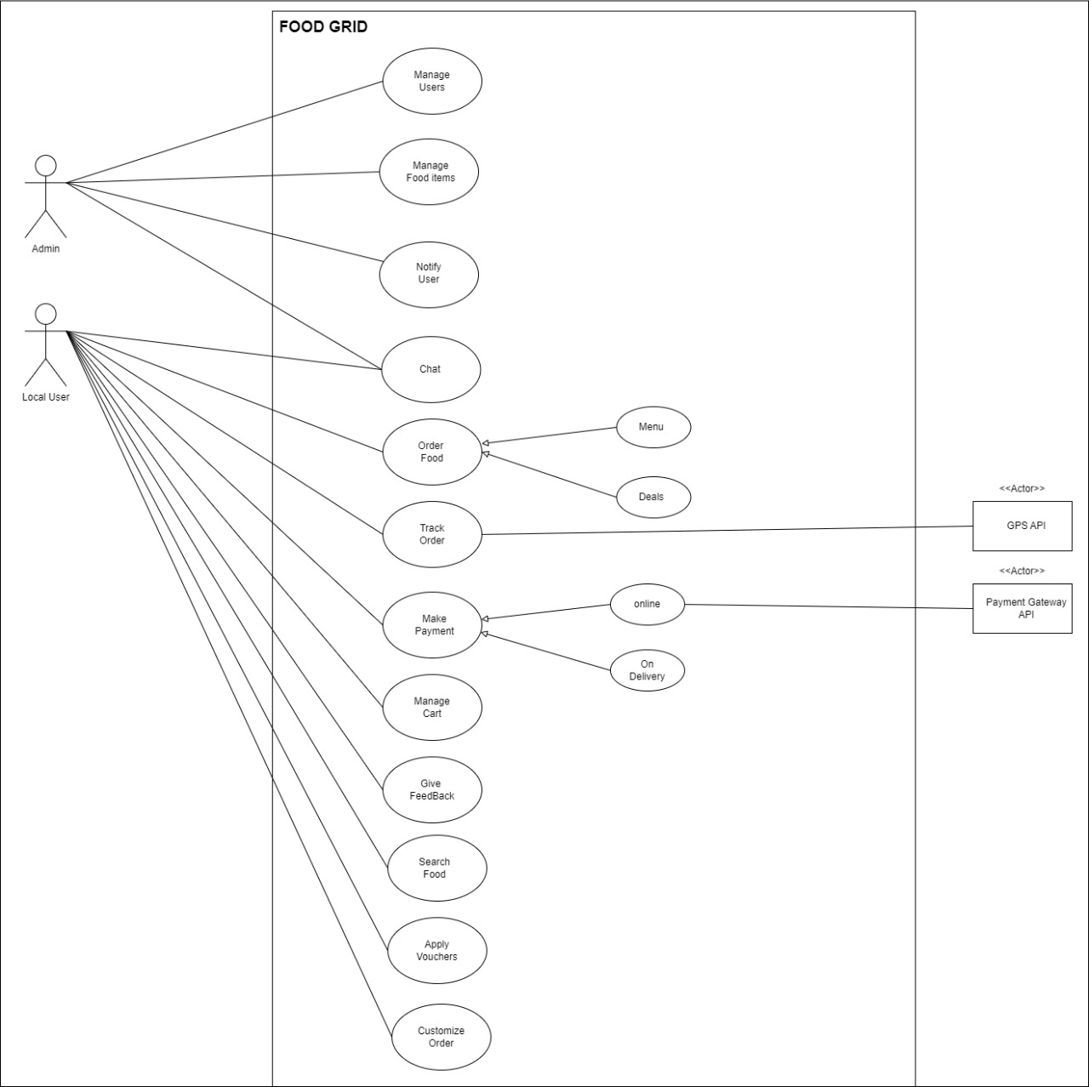

Figure Use case Diagram

# High Level Use Case Diagram

## 5.1. Manage Users

Table Manage Users

|  |  |
| --- | --- |
| **Use case ID** | 01 |
| **Use case Name** | Manage Users |
| **Actor** | Admin |
| **Type** | Primary |
| **Description** | The admin would be able to add, delete and view record of users interacting with the system. |

## 5.2. Manage Food Items

Table Manage Food items

|  |  |
| --- | --- |
| **Use case ID** | 02 |
| **Use case Name** | Manage Food items |
| **Actor** | Restaurant Staff |
| **Type** | Primary |
| **Description** | The restaurant staff would be able to update, delete and add food items in menu. |

## 5.3. Notify User

Table Notify User

|  |  |
| --- | --- |
| **Use case ID** | 03 |
| **Use case Name** | Notify User |
| **Actor** | Restaurant Staff |
| **Type** | Primary |
| **Description** | The restaurant staff would be able to notify user as food is ready or required timeline |

## 5.4. Chat

Table Chat Handling

|  |  |
| --- | --- |
| **Use case ID** | 04 |
| **Use case Name** | Chat |
| **Actor** | Local user, Restaurant Staff |
| **Type** | Primary |
| **Description** | The user would be able to chat with restaurant in case of any query. |

## 5.5. Order Food

Table Order Food

|  |  |
| --- | --- |
| **Use case ID** | 05 |
| **Use case Name** | Order Food |
| **Actor** | Local user |
| **Type** | Primary |
| **Description** | The user would be able to order food according to his/her exact requirement. |

## 5.6. Track Order

Table Track Order

|  |  |
| --- | --- |
| **Use case ID** | 06 |
| **Use case Name** | Track Order |
| **Actor** | Local user |
| **Type** | Primary |
| **Description** | The user would be able to track the ordered food and get informed with the latest delivery time. |

## 5.7. Make Payment

Table Make Payment

|  |  |
| --- | --- |
| **Use case ID** | 07 |
| **Use case Name** | Make Payment |
| **Actor** | Local user, Restaurant Staff |
| **Type** | Primary |
| **Description** | The user would be able to make payment online or on delivery. |

## 5.8. Manage Cart

Table Manage Cart

|  |  |
| --- | --- |
| **Use case ID** | 08 |
| **Use case Name** | Manage Cart |
| **Actor** | Local user |
| **Type** | Primary |
| **Description** | The user would be able to manage cart. Cart contains the details of ordered food with specific nutrients and ingredients. |

## 5.9. Give Feedback

Table Give Feedback

|  |  |
| --- | --- |
| **Use case ID** | 09 |
| **Use case Name** | Give Feedback |
| **Actor** | Local user |
| **Type** | Primary |
| **Description** | The user would be able to submit the feedback so Restaurant would be able to cope up with the services. |

## 5.10. Search Food

Table Search Food

|  |  |
| --- | --- |
| **Use case ID** | 10 |
| **Use case Name** | Search Food |
| **Actor** | Local user |
| **Type** | Primary |
| **Description** | The user would be able to search the required food |

## 5.11. Apply Vouchers

Table Apply Vouchers

|  |  |
| --- | --- |
| **Use case ID** | 11 |
| **Use case Name** | Apply Vouchers |
| **Actor** | Local user |
| **Type** | Primary |
| **Description** | The user would be able to apply for vouchers |

## 5.12. Customize Order

Table Customize Food

|  |  |
| --- | --- |
| **Use case ID** | 12 |
| **Use case Name** | Customize Order |
| **Actor** | Local user |
| **Type** | Primary |
| **Description** | The user would be able to order customize food to get rid of any allergic items |

# Expended Use Case Diagram

## Manage Users

Table EUC-Manage Users

|  |  |
| --- | --- |
| **Use case ID** | 01 |
| **Use case Name** | Manage Users |
| **Actor** | Admin |
| **Description** | The admin would be able to view, add, update or delete user details. |
| **Trigger** | Admin clicked on manage users |
| **Pre-Condition** | Admin logged in to the system |
| **Post Condition** | Admin managed the user |
| **Normal Flow** | Admin will   * Add users. * Remove users. * Update user’s information * View user details   ­ |
| **Alternative Flow** | NA |
| **Special Requirement** | Availability of Internet |
| **Frequency of Use** | High |

## Order Food

Table EUC-Order Food

|  |  |
| --- | --- |
| **Use case ID** | 02 |
| **Use case Name** | Order Food |
| **Actor** | Local User |
| **Description** | The user logged in to the system and would be able to order desired food from the given menu and deals. |
| **Trigger** | User clicked on order food button. |
| **Pre-Condition** | User must be login. |
| **Post Condition** | User’s order is successfully placed |
| **Normal Flow** | * User orders food from menu. * User orders food from deals |
| **Alternative Flow** | NA |
| **Special Requirement** | Availability of Internet |
| **Frequency of Use** | High |

## Make Payment

Table EUC-Make Payment

|  |  |
| --- | --- |
| **Use case ID** | 03 |
| **Use case Name** | Make Payment |
| **Actor** | Local user, Restaurant staff |
| **Description** | The user would be able to make payment of his/her ordered food. Payment can be done online or cash on delivery. |
| **Trigger** | User clicked on Make payment option |
| **Pre-Condition** | User has ordered the food. |
| **Post Condition** | User made the payment. |
| **Normal Flow** | Make online payment of ordered food. |
| **Alternative Flow** | Make Payment on Delivery |
| **Special Requirement** | Availability of Internet |
| **Frequency of Use** | High |

## Manage Cart

Table EUC-Manage Cart

|  |  |
| --- | --- |
| **Use case ID** | 04 |
| **Use case Name** | Manage Cart |
| **Actor** | Local user |
| **Description** | The user would be able to view the cart to see the details of contained ingredients and nutrients in his/her ordered food. Also, able to view his/her payment details. |
| **Trigger** | User clicked on manage cart option |
| **Pre-Condition** | User has ordered the food |
| **Post Condition** | User managed the cart successfully. |
| **Normal Flow** | * Add items to the cart * Remove items from the cart * View the details from cart. |
| **Alternative Flow** | * Select items from the menu. * Select items from deals. |
| **Special Requirement** | Availability of Internet |
| **Frequency of Use** | High |

## Search Food

Table EUC-Search Food

|  |  |
| --- | --- |
| **Use case ID** | 05 |
| **Use case Name** | Search Food |
| **Actor** | Local User |
| **Description** | The user would be able to search food by name, calories or by name of specific ingredients. |
| **Trigger** | User clicked on search bar. |
| **Pre-Condition** | User must be logged in. |
| **Post Condition** | User gets the list of searched food. |
| **Normal Flow** | User searches for food and finds it. |
| **Alternative Flow** | NA |
| **Special Requirement** | Availability of Internet |
| **Frequency of Use** | High |

## Customize Order

Table EUC-Customize Order

|  |  |
| --- | --- |
| **Use case ID** | 06 |
| **Use case Name** | Customize Order |
| **Actor** | Local User |
| **Description** | The user would be able to order food by selecting items like bread, flavors, spices, vegies, sauces, and slices. |
| **Trigger** | User clicked on custom order button. |
| **Pre-Condition** | Users must be logged in and required ingredients are available for order. |
| **Post Condition** | User order is successfully placed |
| **Normal Flow** | User orders the food by   * Selecting Ingredients * Removing Ingredients |
| **Alternative Flow** | * Select food from the menu. * Select food from deal. |
| **Special Requirement** | Availability of Internet |
| **Frequency of Use** | High |

## Manage Food Items

Table EUC-Manage Food Items

|  |  |
| --- | --- |
| **Use case ID** | 07 |
| **Use case Name** | Manage Food items |
| **Actor** | Admin |
| **Description** | The admin would be able to view, add, update or delete items. |
| **Trigger** | Admin clicked on manage food items |
| **Pre-Condition** | Admin logged in to the system |
| **Post Condition** | Admin managed food items |
| **Normal Flow** | Admin will   * Add items * Remove items * Update items * View items |
| **Alternative Flow** | NA |
| **Special Requirement** | Availability of Internet |
| **Frequency of Use** | High |

# System Sequence Diagram

## Manage Users

Figure SSD-Manage Users

## Order Food

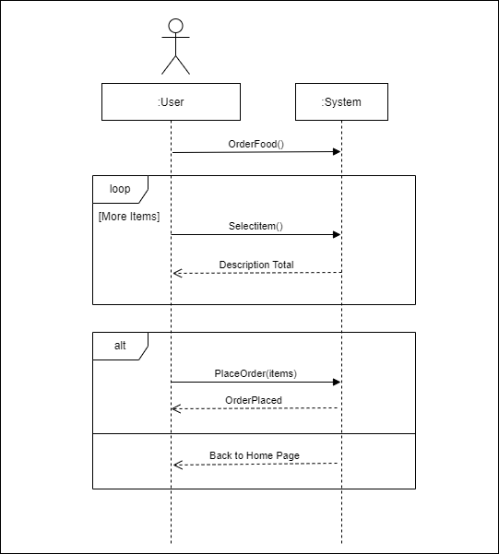

Figure SSD-Order Food

## Make Payment

Figure SSD-Make Payment

## Manage Cart

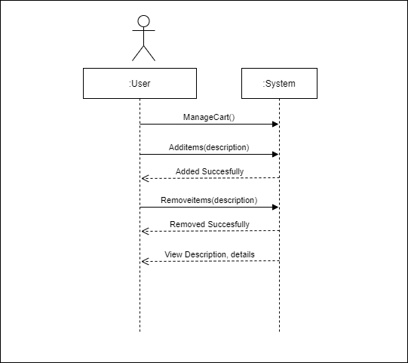

Figure SSD-Manage Cart

## Search Food

Figure SSD-Search Food

## Customize Order

Figure SSD-Customize Order

## Manage Food Items

Figure SSD-Manage Food items

# Activity Diagram

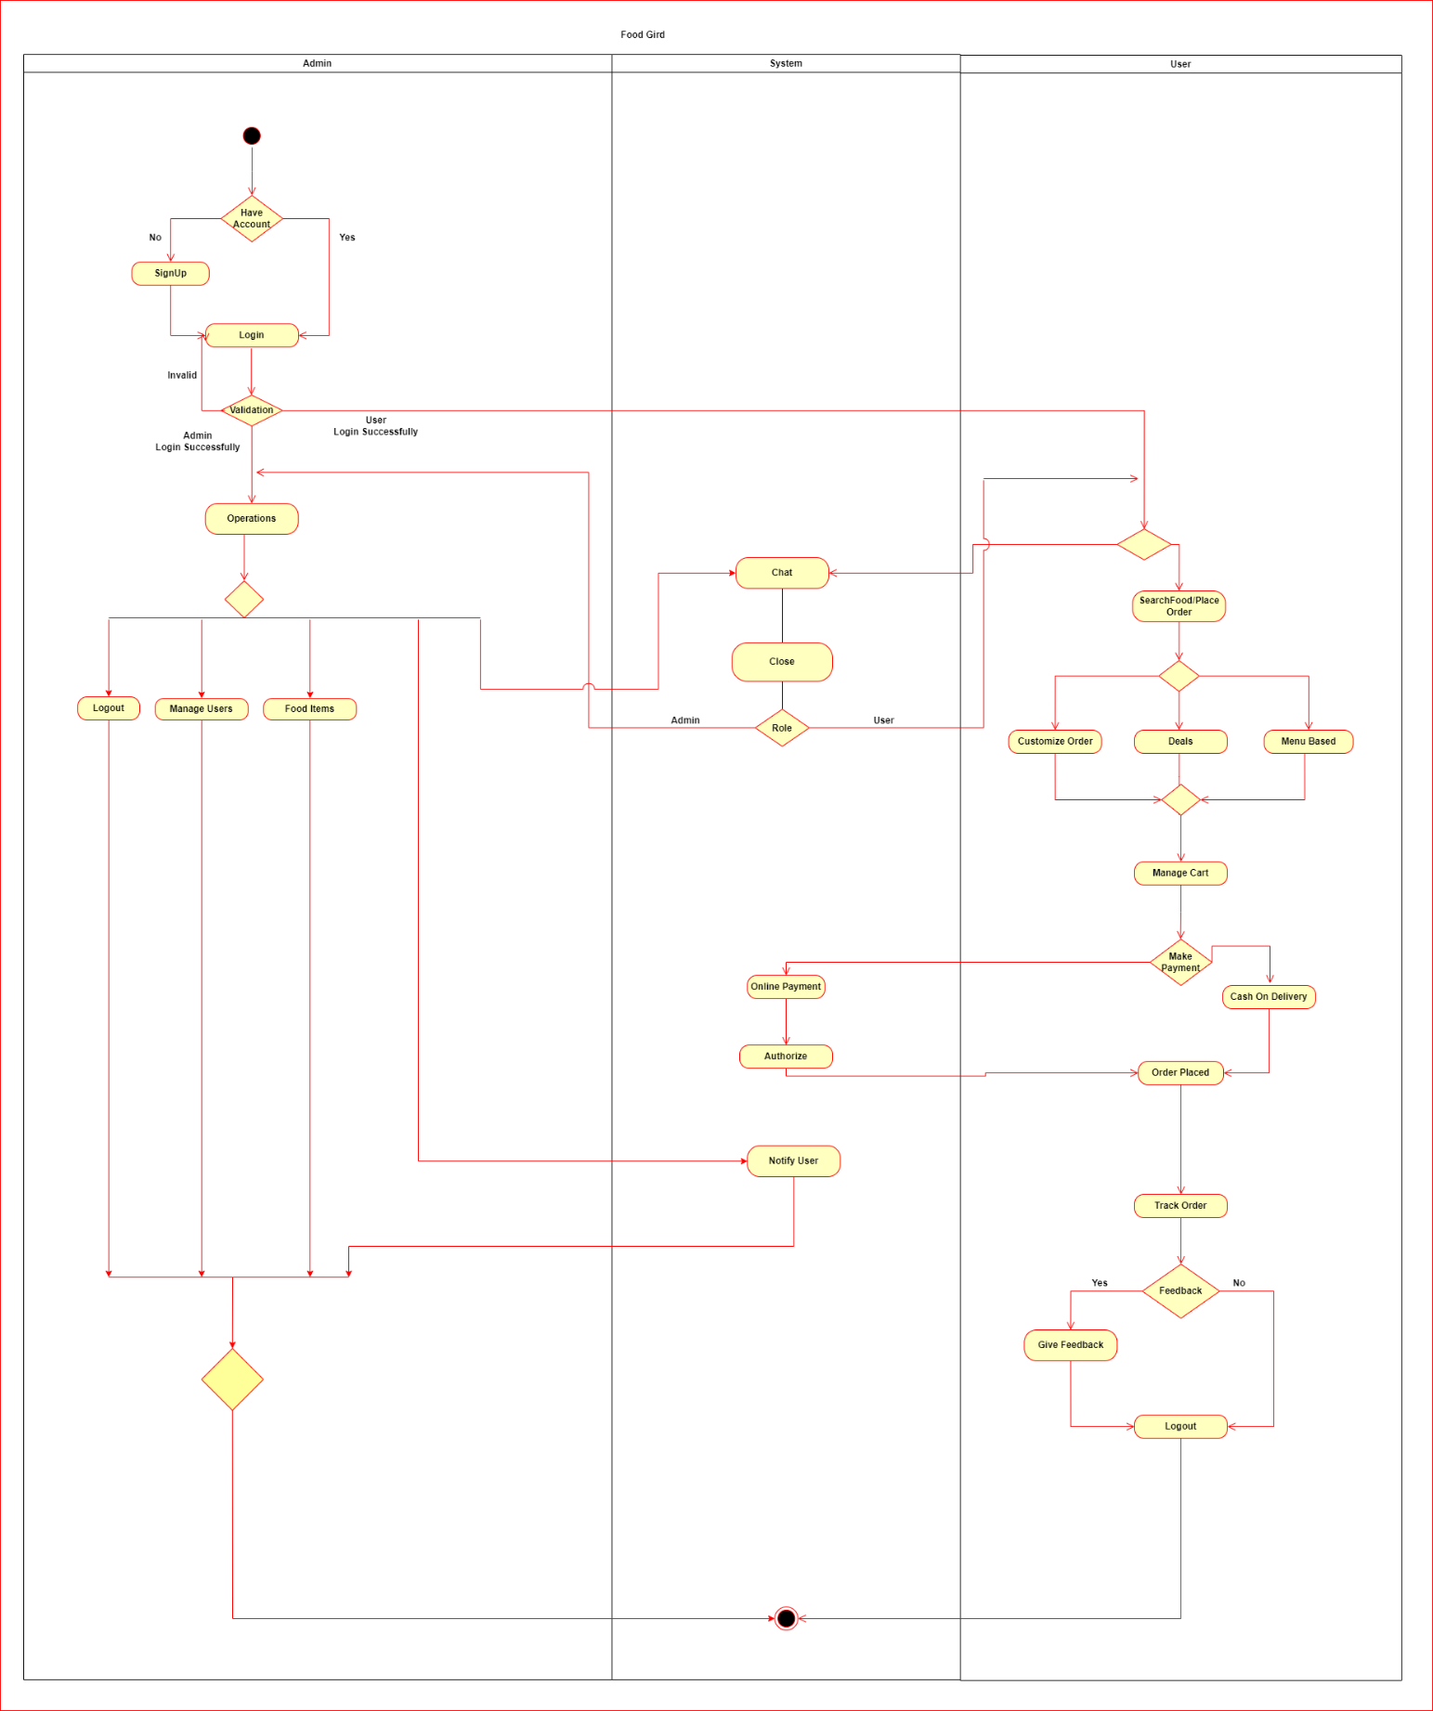

Figure Activity Diagram

# Data Flow Diagram

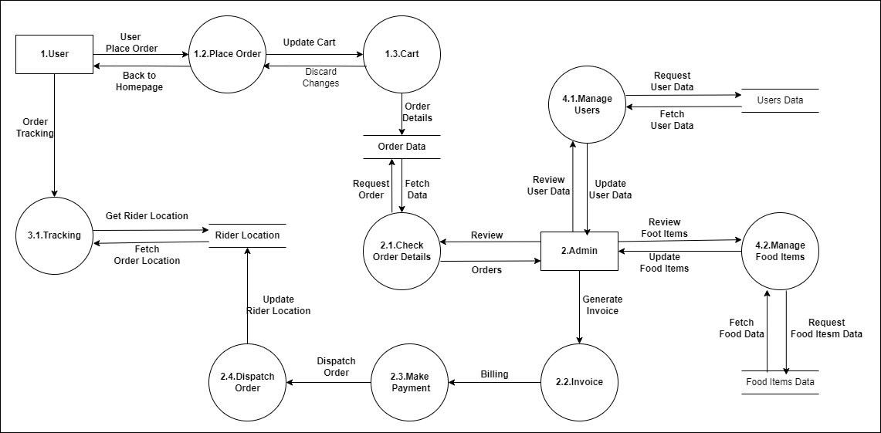

Figure Data Flow Diagram

# State Machine Diagram

Figure State Machine Diagram

# Schema

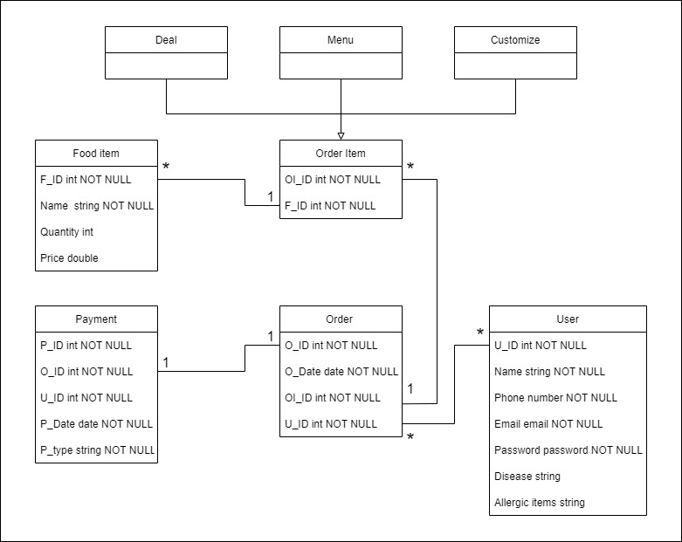

Figure Schema

# Package Diagram

Figure Package Diagram

# Architecture Diagram

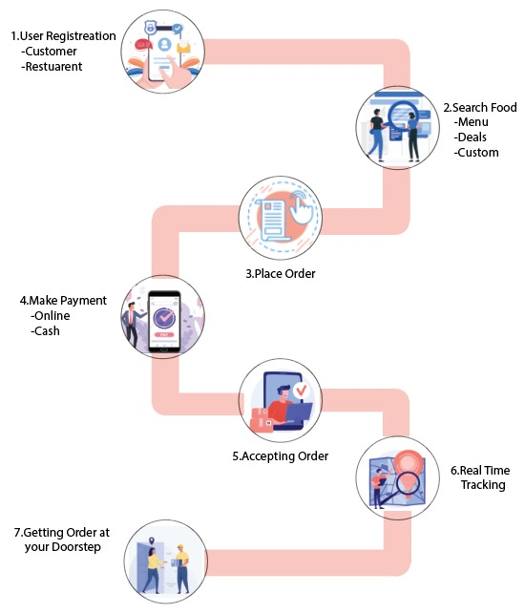

Figure Architecture Diagram